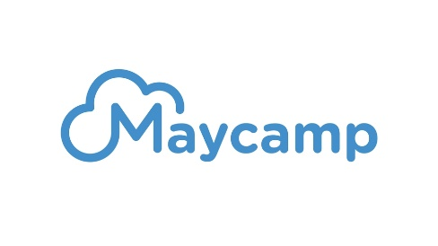

CHAOS 2022

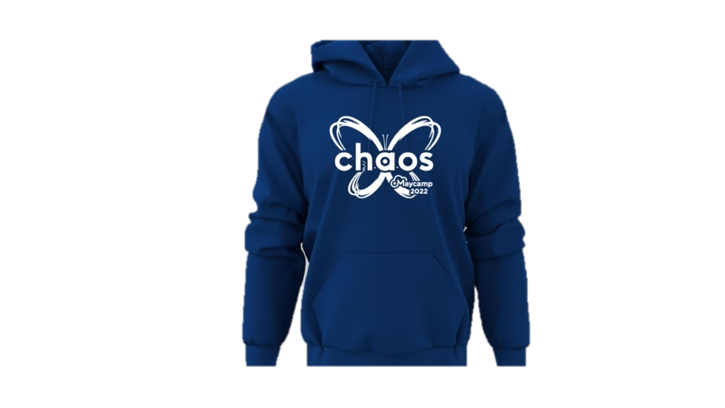
Hoodies Order Form

Church/Youth Group:
Invoice Address:
Contact Name:
Contact Email:
Contact Number:

Please indicate in the table below how many hoodies you would like to order. The picture is not the exact colour of the hoodies.

Adult Sizing | s (34/36 or 6/8) | m (38 Or 8/10) | l (40/42 OR 12) | Xl (44/46 OR 14) | XXl (48/50 OR 16)
Indigo
Children Sizing | 7-8 yrs (30in) | 9-11 Yrs (32/34)
Dark Heather

Hoodies are £30 each regardless of size.
Children’s colours are named different but appear very similar.
They will be available to collect from Info Point on arrival when registering at Maycamp.
Please return this form by 1st May via email: youth@chichester.anglican.org

