May Camp 2020 Hoodies

Hoodies Order Form
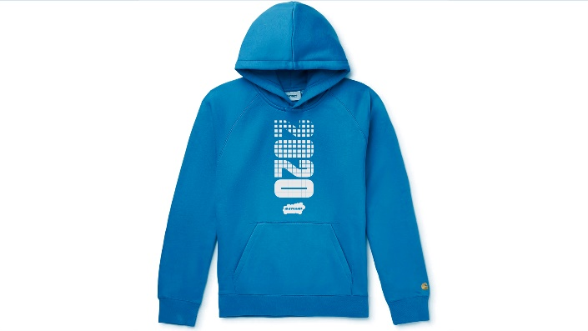

Sample Only

Church/Youth Group:
Invoice Address:
Contact Name:
Contact Email:
Contact Number:

Please indicate in the table below how many hoodies you would like to order
Adult Sizing | s (34/36 or 6/8) | m (38 Or 8/10) | l (40/42 OR 12) | Xl (44/46 OR 14) | XXl (48/50 OR 16)
Grey
Blue
Black
Red
Children Sizing | 7-8 yrs (30in) | 9-11 Yrs (32/34)
Grey
Blue
Black
Red

Hoodies are £20 each regardless of size or colour.
All colours are appoxomite.
They will be available to collect from Info Point when group leaders are registering at May Camp.
Please return this form by April 24th 2020 via email: youth@chichester.anglican.org or post:
FAO: MAY CAMP- Dani Taylor, Diocesan Church House, 211 New Church Road, Hove, BN3 4ED

