Wildfire May Camp 2019

Hoodies Order Form
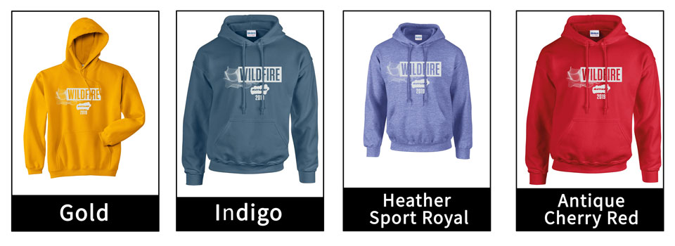

Church/Youth Group:
Invoice Address:
Contact Name:
Contact Email:
Contact Number:

Please indicate in the table below how many hoodies you would like to order
Adult Sizing | s (34/36 or 6/8) | m (38 Or 8/10) | l (40/42 OR 12) | Xl (44/46 OR 14) | XXl (48/50 OR 16)
Heather Sport Royal
Gold/Mustard
Indigo
Antique Cherry Red
Children Sizing | 7-8 yrs (30in) | 9-11 Yrs (32/34)
Heather Sport Royal
Gold/Mustard
Dark Heather
Garnet

Hoodies are £20 each regardless of size or colour.
Children’s colours are named different but appear very similar.
They will be available to collect from Info Point when registering at May Camp.
Please return this form by 29th April via email: youth@chichester.anglican.org or post:
FAO: MAY CAMP- Dani Taylor, Diocesan Church House, 211 New Church Road, Hove, BN3 4ED

